Andrews University
School of Education

FINAL SYNTHESIS PAPER AND MICAH 6:8

In Partial Fulfillment
Of the Requirements for the Degree
Doctor of Philosophy

By
Gary Thurber
July 2026

Contents
Introduction 3
Organization of the Paper 6
Micah 6:8 and my Leadership Journey 7
The Competencies 9
Leadership and the Self 10
Leaders and the Self as it relates to Micah 6:8 11
Leadership Synthesis and Application 13
Leadership With Others 14
Leadership With Other and Micah 6:8 15
Leadership Synthesis and Application 16
Leadership and Organizations 18
Leadership and Organizations and Micah 6:8 19
Leadership Synthesis and Application 20
Leadership and Research 22
Leadership and Research and Micah 6:8 22
Leadership Synthesis and Application 23
Leadership During a Crisis 24
Leadership During a Crisis and Micah 6:8 24
Leadership Synthesis and Application 25
My Leadership Journey 26
Summary 27
Reference List 29

Introduction
As one begins to finish the PhD program in Leadership at Andrews University, one of the final assignments is to write a synthesis paper to give an overview of your learning experience for the PhD program. Andrews Leadership Handbook describes this paper this way:
A synthesis paper expresses the participant’s beliefs about the leadership development, which typically involves an explanation of their transformational learning during the leadership program. It is not an academic treatise but can contain theories and a knowledge base. It is critical reflection in the light of their core values as well as the values of the Leadership community. The synthesis paper integrates the competencies into a unique whole that captures conceptually what leadership means to the participant. In this way it becomes the counterpart to the participant’s vision statement first developed in the LLP. The vision statement and synthesis paper represent the two bookends of the Leadership program. Thus, the synthesis paper is an opportunity for the participant to show evidence of personal and professional growth (Leadership Handbook, 2014, pp. 63-64).
Having the privilege of being a part of this program has been transformational in my learning and leadership journey. First, I want to call out the professors who teach in the leadership program. I did not work with one professor who was not patient and understanding of my journey trying to work full time as a Union administrator while being a part of the program. They were simply wonderful, each one of them. Secondly, I need to mention two professors in particular. Dr. Baumgartner and Dr. Ledesma. Both were my lead advisors at one point or another during my journey. Each of them provided guidance and encouragement that money simply cannot buy. What they gave can only come from a heart of service and grace.
Finally, I was assigned a cohort I have had the privilege of journeying with from the start. To say they have been helpful would be a tremendous understatement. They have become friends, coaches, encouragers and accountability partners in the learning endeavor. I learned so much from them and being with them. I simply would not have made it without them. Below are a few pictures of this group I have come to love.
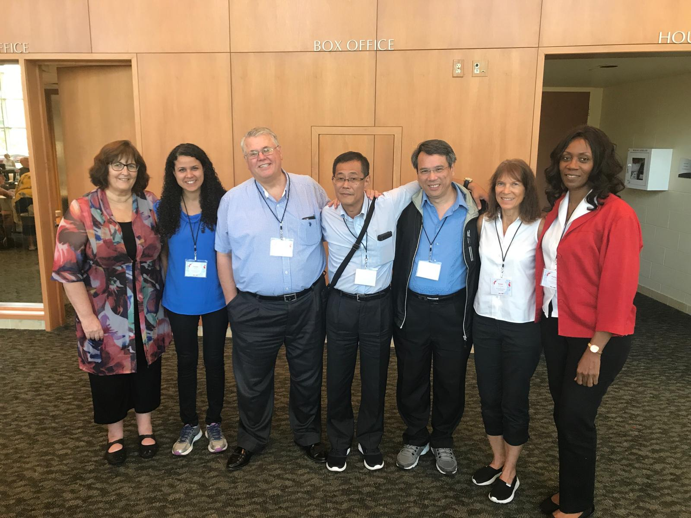
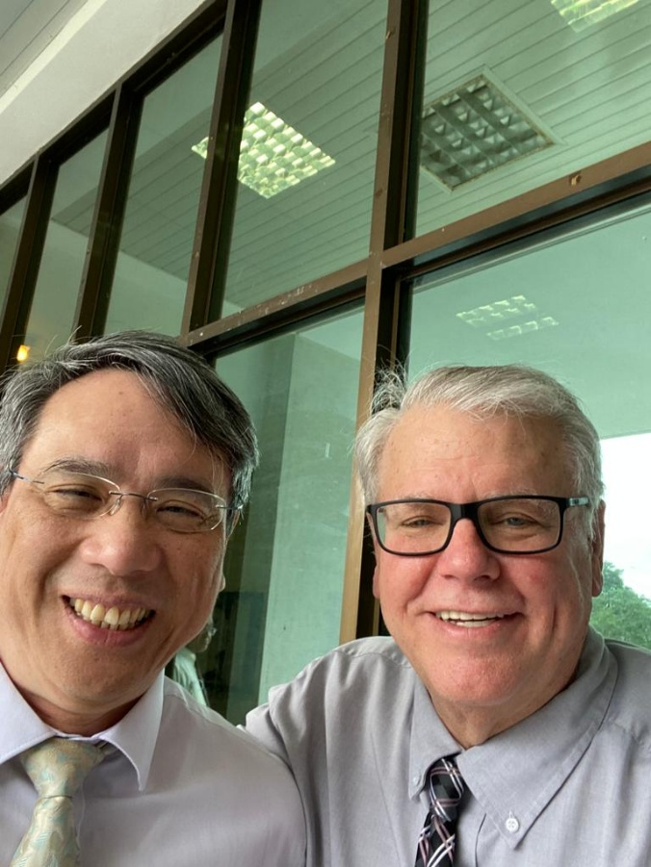

Above is a picture of some of my cohort group. Unfortunately, I do not have a picture with everyone who has been on this journey with me as part of my cohort. As a group, we were scattered all over the world, so we called ourselves, “Global Express.” Some in the first picture have already finished and a few of us are getting close. The second picture is of myself with Dr. Terry Tsui, who is the president now of Taiwan Adventist University. He was one of the first in our cohort to finish the program. This picture was taken at his university in Taiwan.
The learning in this program took place by taking classes, working on competencies and writing reflection papers for them, by meeting regularly with my cohort team, the annual roundtable program, and writing and defending a dissertation.
This program help you get organized for the learning journey you would be on by having you create Lifelong Learning plan, (LLP). With the LLP, you outlined your learning journey for the program including the classwork needed for graduation, the development of the competencies and the timing of the program.
As I look back at my LLP, I wish I could say I was right on schedule according to the plan I created in the beginning. At the same time, I have to give myself some allowances simply because trying to work full time and completing a PhD program was just not easy or predictable. This is where I give credit to my professors and advisors for being patient and talking me through the delays and setbacks.
Much of what I needed to learn was to organize myself at a higher level so as to be able to accomplish all of my academic goals. This did not come naturally to me, and I was stretched farther than I knew I could be. In the end, it was all a blessing to me as I believe the program helped me become a better leader, which was my goal from the beginning.

Organization of the Paper
This synthesis paper will use the Micah 6:8 motif throughout. Michah 6:8, “He has told you, O man, what is good; and what does the Lord require of you but to do justice, to love kindness, and to walk humbly with your God” (New American Standard Bible, 1995), addresses the standard for which I want my leadership to reflect. I will first go into more detail as to why I have chosen Micah 6:8 to guide my leadership experience.
Next I will walk through each of the competency clusters and explain how each have enriched my leadership journey. The last section will be a reflection on my part as to how I have grown as a leader and how to keep pace with an ever-changing world. This paper is not meant to be an academic piece, rather a personal exercise to describe how this academic discipline has caused me to grow and relate to my life experiences in a different way.

Micah 6:8 and my Leadership Journey
Micah 6:8 has become more than a familiar biblical text to me; it has become a concise and compelling model for the kind of leader I desire to become. The verse states, “He has told you, O man, what is good; and what does the Lord require of you but to do justice, to love kindness, and to walk humbly with your God” (New American Standard Bible, 1995). In only a few words, this passage brings together three essential dimensions of leadership: moral courage, compassionate service, and spiritual humility. As I reflect on my leadership journey, I see this verse as both a calling and a corrective. It calls me toward a higher standard of influence, and it corrects the temptation to measure leadership only by productivity, position, or achievement.
The call to “do justice” reminds me that leadership must be rooted in what is right, not merely in what is convenient or efficient. In administrative leadership, decisions often affect people in ways that are not immediately visible. Policies, budgets, personnel decisions, and organizational priorities can either create space for people to flourish or unintentionally place burdens upon them. Micah 6:8 challenges me to consider whether my leadership decisions reflect fairness, integrity, and concern for those whose voices may not be the loudest in the room. To do justice means I cannot be passive when inequity, exclusion, or unfairness appears. It requires me to lead with moral attentiveness and to ask whether my actions align with God’s character and with the mission of the organizations I serve.
The phrase “to love kindness” speaks deeply to the relational side of leadership. Leadership is not only about setting direction; it is also about how people experience the leader along the way. Throughout my journey, I have been the recipient of kindness, patience, encouragement, and grace from professors, advisors, colleagues, and cohort members. Their support has reminded me that kindness is not weakness. Rather, kindness can be a powerful expression of strength when it is joined with truth, accountability, and genuine concern for others. As a leader, I want people to know that they are valued not simply for what they produce but for who they are as children of God. Loving kindness means creating an environment where people feel heard, supported, challenged, and respected.
The final phrase, “to walk humbly with your God,” may be the most important part of the verse for my leadership development. Humility reminds me that leadership is stewardship before it is status. Whatever influence I have been given is not ultimately mine to possess, but mine to use faithfully in service to God and others. The PhD journey has reinforced this lesson in many ways. There have been seasons of progress and seasons of delay, moments of confidence and moments when I was reminded of my limitations. These experiences have taught me that humility is not self-doubt; it is dependence. It is the recognition that wisdom, strength, and perseverance come from God, and that I must remain teachable if I am to continue growing as a leader.
Taken together, the three movements of Micah 6:8 provide a balanced model for leadership. Justice without kindness can become harsh. Kindness without justice can become sentimental and avoid difficult decisions. Both justice and kindness without humility can become centered on personal recognition rather than faithful service. Micah 6:8 holds these qualities together and invites me to lead in a way that is principled, compassionate, and surrendered to God. This balance is especially important in Christian leadership, where the goal is not simply organizational success but faithfulness to God’s mission and care for the people entrusted to one’s influence.
As I move forward in my leadership journey, I want Micah 6:8 to function as a personal compass. When I face complex decisions, I want to ask whether justice is being pursued. When I interact with colleagues, employees, students, church members, or community partners, I want to ask whether kindness is evident in my words and actions. When I experience success, criticism, uncertainty, or change, I want to ask whether I am walking humbly with God. If my leadership can increasingly reflect these three commitments, then I believe it will be more faithful, more relational, and more aligned with the purpose for which God has called me to lead.

The Competencies
As I reflect on my journey through the leadership program, I can clearly see how the competencies the program at Andrews are very intuitive for anyone experiencing a leadership role. The competencies come in clusters and as I walk through them, I will not only speak to the influence each one has had on my leadership, but also how they relate to my Biblical text on leadership, Micah 6:8.
Here are the competency clusters for the Leadership program at Andrews University:
1: Leadership and the Self: a. philosophical foundations; b. ethics, values, spirituality; c. learning and human development;
2: Leadership with Others: a. effective communication; b. mentoring/coaching; c. social responsibility;
3. Leadership through Organization: a. resource development – both human and financial; b. legal and policy issues; c. organizational behavior, development & culture; d. implementing change; e. evaluations and assessment;
4. Leadership and Research: a. reading & evaluating research; b. conducting research; c. reporting and implementing research; and
5: Leadership During Crisis: (This was my personal choice for a competency.)
I readily admit writing the reflection papers were not an easy exercise for me. The amount of time I spent on each one just doing the reading and evaluating portion of the research was time consuming and sometimes tedious. In the end, however, I must acknowledge these competencies perhaps gave me a greater foundation for leadership then anything else I experienced in the program. They are wholistic in nature when you look at them together.
I will also say, while grappling with the various leadership theories associated with each competency was not always easy, it stretched my mind and I believe has molded me into a better critical thinker. I will also say that the competencies reminded me of the truths found in Micah 6:8 which I believe are good for any leader.

Leadership and the Self
This first set of competencies are described by Andrews University Leadership program as (Andrews University, 2017):
. Leadership and the Self: This cluster of competencies focuses on the self-awareness and the personal and professional identity required when practicing leadership.
- Philosophical foundations – Leadership functions within the context of multiple perspectives and understands how their own worldview influences their practice.
- Ethics, values, and spirituality – Leadership functions from a set of principles and standards that guides their work and all their relationships with others.
- Learning and human development – Leadership is committed to and practices continuous personal, interpersonal, group, and organizational learning.
While matriculating through the program, one leadership theory which became meaningful to me was Authentic Leadership. One tenet of this theory is that you need to be able to lead yourself before you can lead others (Caza & Jackson, 2011). When you are honest with yourself, this is a very large task, but a must if you want to be an effective leader. If you can’t lead yourself, you are asking people to do what you can’t or won’t do. This never works well in any leadership setting.

Leaders and the Self as it relates to Micah 6:8
Micah 6:8 relates directly to the Leadership and the Self cluster because the verse begins with the inner life of the leader before it moves to the public practice of leadership. To “do justice, to love kindness, and to walk humbly with your God” requires more than external behavior; it requires a formed character, a clear set of values, and a willingness to examine one’s motives. In this sense, Micah 6:8 speaks to the heart of self-awareness. A leader cannot consistently practice justice, kindness, or humility without first understanding the worldview, assumptions, and personal values that shape his or her decisions. The Leadership and the Self cluster helped me recognize that effective leadership begins with honest reflection about who I am, what I believe, and how those beliefs influence the way I lead.
The phrase “do justice” connects with the philosophical foundations of leadership because every leader operates from some understanding of what is right, fair, and meaningful. Leadership is never value-neutral. The way a leader defines success, treats people, makes decisions, and responds to conflict is shaped by an underlying philosophy of leadership and life. Micah 6:8 reminds me that my philosophy of leadership must be grounded in God’s concern for justice and righteousness. This means that my leadership cannot be guided only by efficiency, organizational tradition, or personal preference. Instead, I must continually ask whether my actions reflect fairness, integrity, and concern for the people affected by my decisions.
The call to “love kindness” relates closely to ethics, values, and spirituality. It is possible for a leader to act correctly but still lack compassion. Micah 6:8 challenges me to consider not only whether I am making the right decision, but also whether I am making that decision in the right spirit. Kindness is not merely a personality trait; it is a value that must be intentionally practiced in relationships. In my own journey, this has meant recognizing that people need patience, encouragement, honesty, and grace. Leadership and the Self has helped me see that my spiritual commitments should be visible in how I speak, listen, correct, support, and respond to others.
The invitation to “walk humbly with your God” is especially meaningful in relation to authentic leadership. Authentic leadership requires self-awareness, relational transparency, internalized moral perspective, and balanced processing. Humility makes these qualities possible because it allows a leader to admit limitations, receive feedback, learn from others, and remain dependent on God. As I have moved through the leadership program, I have been reminded that growth does not come from pretending to have all the answers. Growth comes from being teachable. Walking humbly with God means that I must continually submit my leadership identity to God’s shaping influence and remain open to correction, growth, and transformation.
Micah 6:8 also connects to learning and human development because the verse describes an ongoing way of life rather than a single leadership action. The command to “walk” suggests movement, progress, and daily faithfulness. Leadership development is not completed in one class, one degree, or one position. It is a lifelong process of becoming more aware, more disciplined, more compassionate, and more faithful. This understanding has been important for me because the PhD journey has required persistence, patience, and a willingness to grow in areas that did not always come naturally. The Leadership and the Self cluster has reminded me that the most important leadership work often begins internally before it becomes visible externally.
Therefore, Micah 6:8 gives spiritual and practical meaning to the Leadership and the Self cluster. It reminds me that the leader I am becoming is shaped by the values I hold, the spiritual commitments I practice, and the humility with which I continue to learn. If I am to lead others well, I must first allow God to form justice, kindness, and humility within me. In that way, this competency cluster is not simply about personal improvement; it is about character formation. It calls me to become the kind of leader whose inner life and public leadership are consistent with the biblical model I have chosen to guide my journey.

Leadership Synthesis and Application
My first class challenged me to clearly state what my worldview was. This was a challenging exercise which sent me on a journey which taught me what I believe is more important than why I believe it (Sire, 2020). My second class challenged me to come up with my own leadership theory. After studying many different leadership theories, it was a daunting task, but one in which sent me to my very core to understand how and why I lead.
These philosophical foundations were wisely taught at the beginning of this learning process as to lay a foundation for better understanding of the world around me and how to relate to it and be a leader. Another important part of the journey that took place right in the beginning was I was given a battery of tests which helped me understand better who I was and how I learn and lead. While the testing did not share anything revolutionary with me, it did help me understand at a deeper level who I am and how I am built when it comes to learning.
I believe one of the most important classes I took was on ethics. This class caused me to examine the honesty in which I did most everything. One major application was simply how I studied the Bible. I believe for most of my life I studied the Bible with the intent for it to say what I believed as opposed to letting it say what it says. This was more subconscious than conscious but applied to both my own personal wants but also to the foundational beliefs of my church. Bringing a newfound honesty to studying the Bible was absolutely revolutionary for me and refreshing.
The competency on ethics, values, and spirituality also caused me to reflect on what made my organization tick. One organization I chair the board for, AdventHealth, went through a process where they wanted to identify how patients would be treated if they came to their institution. They identified four salient actions in terms of how they related to their patient: they would love them, own the problem, make things simple, and keep them safe. These promises to their consumers wraps around the ethical, valued based, deeply spiritual approach that all Christian organizations should adhere to.
Finally, being a life-long learner is one of my core beliefs. Understanding how to lead an organization in a process of growing and learning was one of the intentional growth areas I have experienced as I went through this program. Because of having to relate and reflect on the competency on learning and human development, it changed the way we organized and implemented staff meetings, board meetings, department meetings, pastors’ meetings, and even the presidential meetings. Understanding the time commitments for each of the participants was a big deal and thinking through how each group learned best and then how to implement it was a very important part of incorporating this competency in a meaningful way.

Leadership With Others
As defined by Andrews University’s Leadership Program, Leadership with Others is a “cluster of competencies focuses on the interpersonal aspects of leadership. Growth and development of others is an essential function of leadership” (Andrews University, 2017).
- Effective communication – Leadership fosters effective communication in all internal and external interactions, to establish and maintain cooperative
relationships.
- Mentor/coach – Leadership promotes relationships that are trust-centered,
providing the kind of empowerment that results in personal and performance
improvement toward satisfying mutual objectives.
- Social responsibility – Leadership is accountable to others and endeavors to see that family, community, and environmental needs are met in local and, as appropriate, in global ways.
These valuable competencies speak to the core of how a leader will relate to those he or she is serving. When you internalize the heart of what these competencies are revealing to your leadership journey, it makes you stop and think through whether or not you are providing the kind of environment conducive to good collaboration and mission focus.
First I will speak of how these competencies relates to my Biblical foundation of leadership found in Micah 6:8, and then I will write a section on synthesis and application for these competencies.

Leadership With Other and Micah 6:8
Micah 6:8 relates naturally to the Leadership with Others cluster because this cluster focuses on how leadership is practiced in relationship with people. The call to “do justice” reminds me that effective communication must be honest, clear, and fair. Communication is not simply the transfer of information; it is also a way of honoring people. When leaders communicate with transparency and respect, they help create trust, reduce confusion, and give others the information they need to participate meaningfully in the mission of the organization.
The phrase “love kindness” also speaks directly to mentoring and coaching. A leader who loves kindness does not merely direct people but invests in them. Mentoring and coaching require patience, encouragement, listening, and a willingness to help others grow into the people God has called them to become. In this way, Micah 6:8 reminds me that leadership with others should be relational and developmental, not simply task-oriented.
Finally, the call to “walk humbly with your God” connects with social responsibility because humility keeps leadership from becoming self-centered. A humble leader recognizes that leadership is accountable to God and to the people being served. This means paying attention to the needs of families, communities, churches, and the broader world. For me, Micah 6:8 challenges leadership with others to be marked by fairness in communication, kindness in development, and humility in service.

Leadership Synthesis and Application
If there is one certainty about leadership, it is a relationship with others because leadership in isolation is leadership, it is loneliness. We are part of organizations with a purpose, as set of values and a clear mission. I don’t believe I have found anything more important than to be diligent about communicating to all of the constituencies you serve.
Not only do you have to be diligent about that, but you also have to find new ways to communicate what is important. Simply putting out a Union paper is not entirely effective anymore. Every generation that comes along seems to find there news through different channels. Our communication department has worked very hard to keep up with the latest ways in which society now operates in. This means they are involved in social media, web-publishing and electronic newsletters just to name a few.
It is not just how to communicate but thinking through who I need to be communicating to. It is my office staff and departmental leaders about how we will work together to accomplish our mission. It is communication with the conference presidents who I serve directly to. It is the constituents of the Mid-America Union I need to inform as together we work together for the Lord. It is my leadership at the NAD and GC who have much broader constituencies than I do to relate with. If I am not communicating with them, I will not be able to inform my field as to the plans the NAD or GC have for the world church.
Learning to be prepared to communicate clearly with transparency during a time of crisis is also something working through these competencies made clear was paramount. We cannot stop bad things from happening in a broken world, but as we respond to crisis, we need to do so in a way which reflects our character and heart for others. Always protecting people’s dignity must be paramount.
How we mentor and coach our team is something that simply can’t be ignored. We are called to grow those we work with using whatever means we have. This means we protect in our budgets ways in which we can invest in our employees. This means we will coach people to leave room in their schedules to learn and grow in their personal work journey.
Mid-American Union has bent over backwards to help me grow while leading. The office staff has given me allowances to do the work it takes to finish a doctoral program. They have also supported me financially to make this journey a reality. In turn, if I am going to practice the Golden Rule, I am going to open any doors I can for the people I serve to grow in their journey.
Being a Christian organization, we must pray for the mind of Jesus. In doing so, it will make us sensitive to the injustices that occur in our society and around the world. In this society right now, it is an especially tricky road to walk down. While there are people who claim you are to “woke” if you stand up for a social issue we are facing, we must not let bully voices keep us from doing the right thing and standing for the right thing. Donning the essence of being a Christian organization pushes up to the very top of being an ethical and responsive organization to the people we serve and to the community.

Leadership and Organizations

. Leadership through Organizations: This cluster of competencies focuses on the organizational aspects of leadership. Leadership sets direction in ways that facilitate achievement of organizational goals (Andrews University, 2017).
- Resource development, human and financial – Leadership appropriately allocates and manages human and financial resources for healthy and strategic
outcomes.
- Legal and policy issues – Leadership applies and understands the scope of a
legal and policy structure appropriate for their field.
- Organizational behavior, development, and culture – Leadership understands
personal, group, and inter-group behaviors, and how they impact organizational
history, needs, and goals.
- Implementing change – Leadership involves working with others in order to
collaboratively shape the vision and strategy for change, as well as being capable of facilitating the change process.
- Evaluation and assessment – Leadership uses appropriate evaluation and
assessment tools to make decisions about programs and plans.

Leadership and Organizations and Micah 6:8
Micah 6:8 relates strongly to the Leadership and Organizations cluster because organizations are one of the primary places where leadership values become visible. The call to “do justice” reminds me that organizational leadership must be concerned with fairness in policies, resource allocation, decision-making, and accountability. Whether working with human resources, budgets, boards, or institutional priorities, justice requires leaders to ask whether people are being treated equitably and whether the organization’s practices reflect its stated mission.
The phrase “love kindness” speaks to the culture an organization creates. Policies and structures are necessary, but they should never cause leaders to forget the people those structures are meant to serve. In a Christian organization, kindness should be reflected in how employees are supported, how conflict is addressed, how change is communicated, and how people are encouraged to grow. Micah 6:8 reminds me that healthy organizational culture is not built only by strategy, but also by compassion, trust, and care.
The instruction to “walk humbly with your God” also challenges how leaders approach organizational change and assessment. Humility reminds me that no leader or organization has all the answers. Evaluation, feedback, and assessment are important because they help leaders listen, learn, and make needed adjustments. Walking humbly means being willing to examine whether programs are working, whether decisions are producing the intended outcomes, and whether God may be calling the organization to grow in new ways.
For me, this competency cluster shows that leadership is not only personal or relational; it is also organizational. Micah 6:8 gives a biblical framework for leading systems, not just individuals. It calls me to help shape organizations that are just in their decisions, kind in their culture, and humble enough to keep learning. In that way, the verse becomes a guide for both the heart of the leader and the health of the organization.

Leadership Synthesis and Application
Mardian Blair, a former president of AdventHealth, is quoted for his famous statement, “no margin, no mission.” While there are people who have written articles claiming this is not an appropriate stance for a Christian organization that is supposed to be based on faith, at the core, Mardian I believe is on to something.
One of the biggest parts of my leadership responsibilities is to see there are finances to carry out our mission. For my work at the Mid-America Union, this means we must operate within a budget that makes sure there is money in the bank to cover the salaries each month for our employees, to make sure there are funds to cover the health care cost of our office staff, that we have monies to send back to our conferences for their budgetary requirements, that we send money up to the NAD and the GC so they have money for their mission, and then we look over the Union Adventist University budget to make sure it has the money to operate.
Beyond that, knowing how to raise our income is important as well. As inflation keeps going up, costs for doing ministry do as well. Encouraging thoughtful stewardship among our membership and finding new ways to carry out our mission that are more financially feasible is a must.
Working in a Union office for the SDA church also means you are a resource to all of the conferences when it comes to HR and legal issues we are faced with. It also means we are a resource as the conferences develop and improve upon their constitution and by-laws that govern the work in their field. This is key in helping them establish healthy processes on which to build their leadership foundation.
As a union, we also try to foster and mentor organizations we serve to have a healthy, vibrant culture that make it a joy for people to come and work and for the organization to thrive in its missional endeavors.
Implementing change is something else we must do at the union office and model well for the organizations we serve. Change is inevitable but how we go about it should be a thoughtful process. Done correctly, change can bring strength and sometime relief to an organization. Don poorly, it can cause chaos and lead to bitterness within the organization.
For the most part, people don’t want to change. Talib Hussain once wrote, “the future of this change is uncertain and may concern the people's worth, coping abilities, and competency, so the people of the organization do not support change unless they are convinced against the status quo (Hussain et al., 2018). Understanding the various change theories and using them to build a model for change was something that was an imperative as we had to bring about needed changes in areas that has been ignored for years. In the end, it was vital and necessary to make the changes, and the Mid-America Union was better for it.
One of the most important tasks a union has is helping conferences find new leadership; especially presidential leadership. In order to have a successful search and vote for a new president, proper and invaluable evaluations and assessments must be done on the candidates so committees can make informed decisions. This is also true for when conferences have their constituency meetings and they vote on their president and other officers and in some conference constituency meetings, their departmental directors as well.
As a union, we provide an assessment for constituency meetings done by the pastors and teachers and office workers in the conference. We provide an assessment for them so they can have assurance of the confidentiality of the survey. These assessments help guide a nominating committee in the process of nominating their leadership for the term. During my time as president of the Mid-America Union, I have seen these surveys lead to a change in leadership for the conferences. This is just one way in which evaluation and assessment were critical in practice while providing leadership at the union.

Leadership and Research
Leadership and Research: This cluster of competencies focuses on the need to use data to communicate, persuade, and make decisions, and to contribute to the knowledge base for leadership. Competence in research needs to include both qualitative and quantitative methods. Research skills are often necessary while engaging in organizational development, assessment and evaluation, and other leadership projects (Andrews University, 2017).
- Reading and evaluating research – Leadership critiques the adequacy of research reports, conducts literature reviews using electronic sources, and relates research to the body of knowledge in their professional field.
- Conducting research – Leadership understands the logic and processes of scientific inquiry, explains major research methodologies, formulates empirically-driven research problems, selects appropriate research designs, explains standards for data collection, and conducts basic data collection and analysis.
- Reporting and implementing research – Leadership adequately communicates research findings and implements the findings in the workplace.

Leadership and Research and Micah 6:8
Micah 6:8 relates to Leadership and Research because research helps leaders pursue truth with integrity and make decisions that are just. To “do justice” means that leaders should not rely only on assumptions, preferences, or tradition when important decisions affect people and organizations. Reading, evaluating, and conducting research gives leaders better tools for understanding reality, listening carefully to evidence, and making decisions that are fair, informed, and responsible.
The call to “love kindness” also shapes how research is reported and implemented. Research is not simply about data; it is about people whose lives, ministries, and organizations may be affected by the findings. Kindness requires leaders to communicate findings honestly but carefully, with respect for those involved. Finally, to “walk humbly with your God” reminds me that research requires humility. A leader must be willing to learn, admit what is not yet known, receive correction, and allow evidence to challenge previous conclusions. In this way, research becomes an act of faithful leadership when it is used to seek truth, serve people, and guide organizations wisely.

Leadership Synthesis and Application
Keeling once said, “we do research because we want to understand things better, and we write down what we have observed and learned in order to share it with others, to organize and place it somehow in the pantheon of many things learned by many people over many ages and to find out what difference it makes” (Keeling, 2001). What more does a leader need to know than this to make research a priority in the leadership.
In these three competencies, reading and evaluating literature that is appropriate for the given project, implementation of the research in an ethical and transparent manner, and reporting carefully the findings gives any leader an opportunity to make good decisions and lead and organization in a direction that will most likely bring about mission fulfillment.
My journey through this program has given me insights into research I have never encountered before. I have done research projects in the past, but the research I was mentored into doing for my dissertation took me on an academic journey that opened my eyes to what research was all about.
I can’t help but believe this journey and knowledge will help greatly with any issues I am faced with in the days to come in my leadership role. Reading and evaluating pertinent literature, conducting research in an ethical manner and reporting the results with transparency should be a cornerstone for any leadership foundation.

Leadership During a Crisis
A few years after I began this journey in the leadership program, Covid 19 hit. It was amazing all the different ways this pandemic affected organizations I was connected to. For the church, there was the challenge of closing churches and meeting for worship each week by Zoom. It also meant all of the classrooms were shut down and suddenly our teachers had to finish the year over the internet.
The hospital system was struck with being unable to obtain personal protective equipment, respirators were in short supply, and people were dying alone in their hospital rooms because visitors were not allowed. Universities suddenly not only had to figure out how to have schools online, but also how to provide services with less students financially.
For these reasons, I chose how to provide leadership during a crisis as my personal leadership competency.

Leadership During a Crisis and Micah 6:8
Micah 6:8 provides a meaningful framework for leadership during a crisis because crisis reveals what a leader truly values. In moments of uncertainty, fear, and rapid change, the call to “do justice” reminds me that leaders must make decisions that protect people, preserve dignity, and seek the common good. During a crisis, decisions are rarely easy, and there is often incomplete information. Even so, justice requires leaders to consider how choices affect the most vulnerable and to act with fairness, courage, and integrity.
The command to “love kindness” is also essential in crisis leadership. People do not only need instructions during a crisis; they need reassurance, compassion, and care. Whether leading during a pandemic, an organizational disruption, or a personal tragedy within the community, kindness shapes the way leaders communicate, listen, and respond. It reminds me that policies and decisions must be carried out with empathy, especially when people are grieving, afraid, exhausted, or uncertain about the future.
Finally, “walking humbly with your God” reminds me that crisis leadership requires dependence, prayer, and teachability. No leader can control every outcome in a crisis, and no leader has perfect knowledge. Humility allows a leader to seek counsel, admit limitations, adjust when new information becomes available, and remain grounded in faith. For me, Micah 6:8 teaches that leadership during crisis must be marked by justice in decision-making, kindness in relationships, and humility before God as the leader seeks to serve faithfully in difficult circumstances.

Leadership Synthesis and Application
Besides dealing with the Covid 19 crises mentioned above, we have had to deal with churches who have been torn apart by a sexual predator who molested their children. We have had children who have died some by negligence and some by accident, conferences who had a 20% plus loss in tithe because flooding destroyed the farmland of their constituents, and institutions who have had critical accidents occur again, some by negligence and some by accident.
Leading during a time of crisis call for careful and thoughtful oversight. Communication must be done in a way in which honest, transparent reporting goes out, and at the same time, is careful not to let someone’s dignity be damaged. For any organization, preparing for a crisis must be a part of the strategic planning. Without proper preparation a leader can make a bad situation even worse.

My Leadership Journey
Ever since I graduated from college, I have been in a leadership position. First, as a classroom teacher, though I was the new kid on the block, to the students I had in my classroom, I was a leader. I took my responsibility seriously and after a few months of hard knocks getting started, it became a rewarding experience.
I did spend four years as an associate pastor when my leadership responsibilities were not used the same. While I had areas of the church life I led out in, the main leadership burden rested upon the shoulders of my senior pastor.
After that four-year assignment came to an end, I have been either leading a congregation (there were seven of them), or a youth program with 80 young adults working for me at summer camp, a conference president for three different conferences and a unio president.
I don’t know how this journey came about. It was something I dreamed about wanting to do. On my work-life path others, more than myself, saw me in different roles than I was thinking about doing. It has been a privilege to serve in these leadership positions. I have had opportunities to go places and work with some organizations that truly impact this world for the good.
I felt I needed to grow as I was finishing my time with my third conference as president. I found myself in the proximity of Andrews and learned about the leadership program. I didn’t need a PhD for my work, but I began to think about the good stimulation I would receive from just the course work if nothing else.
I remember during orientation week learning about Kolb’s Learning Cycle and immediately saw ways in which I could apply it in my work context (Kolb & Kolb, 2018). I also learned a lot about myself with the different testing I received.
The classwork and the cohort I was tied into became the center of my learning journey for a number of years. Along the way, the competencies began to shape me as a leader and helped me grow in a strong foundational way as a leader.
The dissertation process where I really began to understand the rigor of research came next. The experience of this program has probably been the most impactful training and mentorship I have received when it comes to understanding leadership. My gratitude is through the roof for all of my professors and cohort members. I have grown to love you all.

Summary
As I reflect on this paper and my journey through the Andrews University Leadership program, I am deeply grateful for the ways this experience has shaped me personally, spiritually, academically, and professionally. What began as a desire to grow as a leader became a transformational process that challenged my worldview, strengthened my understanding of leadership, and stretched me beyond what I thought I could accomplish. Through coursework, cohort conversations, competency reflections, annual roundtables, and the dissertation process, I learned that leadership is not merely a position to hold but a lifelong calling to grow, serve, and remain teachable.
The leadership competencies helped me see leadership as a whole-person practice. Leadership begins with the self, moves into relationships with others, becomes visible through organizations, is strengthened by research, and is tested during times of crisis. Each cluster gave me language and structure for understanding the responsibilities I have carried as a teacher, pastor, conference president, and union president. At the same time, these competencies reminded me that good leadership must be grounded in character, shaped by values, informed by evidence, and practiced with care for the people and organizations entrusted to me.
Micah 6:8 provides the biblical center for this leadership journey. To do justice, love kindness, and walk humbly with God summarizes the kind of leader I want to become and continue becoming. Justice calls me to lead with fairness and courage; kindness calls me to lead with compassion and care; humility calls me to remain dependent on God and open to growth. If this program has taught me anything, it is that leadership is best understood as faithful stewardship. My prayer is that the lessons learned through this journey will continue to shape my leadership so that it reflects God’s character, serves people well, and strengthens the mission of the church and the organizations I have been called to serve.

Reference List
Andrews University. (2017). Leadership Handbook 2017-2018. Retrieved from https://www.andrews.edu/sed/leadership_dept/leadership/resources/handbooks
Caza, A., & Jackson, B. (2011). Authentic leadership. The SAGE Handbook of Leadership, 352-364.
Hussain, S. T., Lei, S., Akram, T., Haider, M. J., Hussain, S. H., & Ali, M. (2018). Kurt Lewin's change model: A critical review of the role of leadership and employee involvement in organizational change. Journal of Innovation & Knowledge, 3(3), 123-127.
Keeling, R. P. (2001). Why and how to publish research in the Journal of American College Health. Taylor & Francis.
Kolb, A., & Kolb, D. (2018). Eight important things to know about the experiential learning cycle. Australian Educational leader, 40(3), 8-14.
Leadership Handbook. (2014). http://www.andrews.edu/sed/leadership_dept/leadership/resources/handbooks/index.html: Andrews University.
New American Standard Bible. (1995). The Lockman Foundation.
Sire, J. W. (2020). The universe next door: A basic worldview catalog. InterVarsity Press.

