Andrews University
School of Education

REFLECTION PAPER

LEADERSHIP THROUGH ORGANIZATION:
3B: LEGAL AND POLICY ISSUES

In Partial Fulfillment
Of the Requirements for the Degree
Doctor of Philosophy

by
Gary F. Thurber
April, 2024

Contents
Introduction 3
Organization of the Paper 4
Legal and Policy Issues 4
How Policy Is Made 6
Implementing Policy 8
Importance of Consistency 9
When Policy and Mission Collide 10
The Church and the Law of the Land 12
Areas of Growth 14
Applying Theory to Practice 14
Bibliography 17

Introduction
This reflection paper covers section 3b of the competencies for the Leadership PhD program at Andrews University. This section is part of the Leadership Through Organization cluster, as outlined in the Andrews University Leadership Handbook (Andrews University, 2017), which includes:
a. Resource development; human and financial—Leadership appropriately allocates and manages human and financial resources for healthy and strategic outcomes.
b. Legal and policy issues—Leadership applies and understands the scope of a legal and policy structure appropriate for their field.
c. Organizational behavior, development, and culture—Leadership understands personal, group, and inter-group behaviors, and how they impact organizational history, needs, and goals.
d. Implementing change—Leadership involves working with others in order to collaboratively shape the vision and strategy for change, as well as being capable of facilitating the change process.
e. Evaluation and assessment—Leadership uses appropriate evaluation and assessment tools to make decisions about programs and plans.
As the Andrews University handbook states, “This cluster of competencies focuses on the organizational aspects of leadership. Leadership sets direction in ways that facilitate achievement of organizational goals” (Andrews University, 2017).
Having served the Seventh-day Adventist Church for more than 41 years as a teacher, pastor, youth director, and administrator at both conference and union levels, I have observed the organization from multiple perspectives. The church’s organizational, legal, and policy structures have significantly shaped both my ministry and my leadership practice. In this paper, I reflect on that journey by examining how legal and policy frameworks have informed my leadership, how relevant theories have shaped my understanding, and where I continue to see opportunities for growth.

Organization of the Paper
This paper focuses on competency 3b, which addresses legal and policy issues. The Andrews University Leadership Handbook defines this competency as the leader’s ability to apply and understand “the scope of a legal and policy structure appropriate for their field” (Andrews University, 2017). Through specific examples and reflective narratives, I will demonstrate how my learning in this competency has been integrated into my leadership journey.

Legal and Policy Issues
The Seventh-day Adventist Church now has approximately 23 million members. In an organization of this size and complexity, policies are essential for maintaining order, strengthening accountability, and supporting mission. Throughout my leadership journey in various parts of the church structure, I have seen policy play an invaluable role in helping the organization function effectively and remain focused on its mission.
There are two main sources of policy for the Seventh-day Adventist Church that primarily address issues facing church organizations and the entities that employ workers: the North American Division policy book, known as the red book, and the General Conference policy book, known as the black book. These are comprehensive books covering almost every conceivable issue a church, employer, or institution might face. Taking the time to learn and implement these policies is critical for anyone in leadership in the Seventh-day Adventist Church.
Other policies that give life to organizing mission are the various constitutions from different entities within the church. Each conference, union, and the General Conference has a constitution that governs how it operates. Schools of higher education and institutions throughout the denomination have constitutions as well. This includes places like Loma Linda University, Andrews University, Pacific Press, and Christian Record Services for the Blind.
One other book, The Church Manual, is not technically considered policy but rather a collection of best practices and guidelines for how to operate a local church. This book also gives a clear outline of the church’s fundamental beliefs as well as its structure.
Policy is most effective when it is developed and implemented within an ethical framework. Conversely, myths, assumptions, and misunderstandings can contribute to ineffective or even harmful policy development. Although policy is a valuable tool for organizational coherence, no policy book can anticipate every circumstance that may arise in ministry or institutional life. In the sections that follow, I describe ways policy has guided and strengthened my leadership, as well as situations in which the absence of policy, or the need for wise exceptions to policy, required careful discernment.
In addition to denominational policy, leaders must maintain a working knowledge of civil law. Areas such as hiring and termination practices, sexual harassment, employee compensation, and nonprofit governance can create serious consequences when misunderstood or neglected. I will therefore also discuss how a clearer understanding of nonprofit law has led to significant changes in my own workplace.

How Policy Is Made
Within the Adventist Church, policies and guidelines arise from the need for coherence across the church’s operations. Employee compensation, benefits, property management, and borrowing funds for capital projects all require clear policies that can be understood and applied consistently.
Because policy shapes organizational behavior, it must be developed with care. For the church, policy should ultimately serve the mission rather than hinder it. Nevertheless, policies can sometimes slow or obstruct mission, even when they were created with constructive intent. Later in this paper, I discuss one situation in which my team encountered a policy that we believed hindered mission and required thoughtful response.
In creating policy, ethics have to come into play at a foundational level. Whether a policy applies to a person or an institution, it must have integrity. Finding out the truth about issues we face is essential to bringing about healthy and productive policy. Judith De Neufville and Stephen Barton argue that myth plays a critical role in policy development. They define myth as “stories which draw on tradition and taken for granted knowledge” (De Neufville & Barton, 1987, p. 1). This can cut both ways in policymaking. De Neufville and Barton go on to argue that “On the one hand, they, (myths), can provide creative inspiration for policies, a way of translating community values into action proposals, and a powerful means to communicate to a broad public and rally support. They can mediate social and economic change by allowing new policies to carry familiar meaning.” Our church can certainly relate to this observation. Many of our traditions and practices have led to creating policy that protects our values and our mission. One example of this is our passion for Christian education. Since the 1870s, having schools as part of our mission has led to our having the largest Protestant school system in the world, with over 7,600 schools, more than 1.5 million students enrolled, and a staff of over 80,000 teachers ("Wikipedia,"). De Neufville and Barton also point out that some myths, traditions, and stories can impede mission as well. They say, “a myth can conceal crucial contradictions and realities, legitimize policies that benefit the powerful, and support anachronistic perceptions of policy problems” (De Neufville & Barton, 1987, p. 1). An example of this for some in the church is the policy not to ordain women. Around the world, however, there are a number of places where not allowing women to be ordained causes a stumbling block. This is one policy my team faced in which we felt mission was being hindered.
R. M. Mthethwa identifies seven critical dimensions of effective policy implementation (Mthethwa, 2012, p. 5):
● the policy, its formulation, and dissemination
● social, political, and economic context
● leadership for policy implementation
● stakeholder involvement in policy implementation
● implementation planning and resource mobilization
● operations and services
● feedback on progress and results
In general, the Seventh-day Adventist Church addresses these seven dimensions well. Policy is voted at the North American Division or General Conference level, but before reaching the floor for a vote, it has typically been reviewed, discussed, and refined at lower levels of church governance. Even then, committee members continue to evaluate the proposal to ensure that the process is thoughtful, representative, and missionally appropriate.

Implementing Policy
Anita Bhuyan, Anne Jorgensen, and Suneeta Sharma, in their article on implementing policy, give three important reasons why it is so important to assess policy before trying to implement it. First, it promotes accountability by holding policymakers and implementers accountable for achieving stated goals and by reinvigorating commitment. Second, it enhances effectiveness because understanding and addressing barriers to policy implementation can improve program delivery. Finally, it fosters equity and quality because effective policy implementation can establish minimum standards for quality, promote access, reduce inconsistencies among service providers and regions, and thus enhance quality (Bhuyan, Jorgensen, & Sharma, 2010, p. 1).
During my years as a summer camp director, new policies often had to be developed annually to meet the needs of the program. Inviting my leadership team into the process early was essential. Their assessments strengthened final policy implementation because they considered accountability, fairness, balance, and practical enforcement. This collaborative process also created ownership among those who would be responsible for applying the policies throughout the summer.

Importance of Consistency
According to Lighthouse Consultants, consistency is also key in implementing policy. They say consistency “Fosters a sense of trust and respect among team members, as they know that they will be held accountable for their actions based on the established policies” (Linkedin, 2023, p. 1).
I agree with Lighthouse Consultants that consistency is one of the most important aspects of policy implementation. Treating employees equitably, regardless of circumstances or status, is essential for maintaining trust and morale. In the Adventist Church, policies address areas such as dress, diet, and moral conduct. When such policies are applied inconsistently, employees may experience confusion, frustration, or a diminished sense of fairness.
The youth camp referenced earlier served more than 200 campers each week and was staffed largely by college-aged adults. These staff members were deeply committed and capable, yet many were still developing the maturity and judgment that come with experience. For that reason, clear policies were necessary to guide staff conduct and protect the integrity of the camp community.
One such policy prohibited male and female staff members from entering one another’s living quarters for any reason. Violation of this policy resulted in immediate dismissal from the staff. One of my earliest tests as camp director occurred when an adult staff member was found in the living quarters of another adult staff member of the opposite sex. Staff members watched closely to see whether adults would be held to the same standard as college-aged employees. Ultimately, I dismissed the adult staff member. Although the decision was painful, it reinforced the importance of consistency, preserved staff trust, and strengthened team morale.

When Policy and Mission Collide
Michael Howlett rightly argues that: “Different aspects and types of failure are often poorly specified and incorrectly juxtaposed, and this conceptual confusion has stood in the way of cumulative theory-building into the causes and consequences of policy success and failure” (Howlett, 2012, p. 545).
In a worldwide church with more than 22 million members, it is reasonable to expect that a single policy book may not always address every local context effectively. As Howlett suggests, however, contextual tension does not necessarily mean that a policy has failed (Howlett, 2012). Rather, it may reveal the need for careful evaluation, adaptation, or contextual application.
One such situation my team encountered was the difference of opinion over a policy the Adventist Church voted in San Antonio at the General Conference Session (Network, 2015). The policy spoke to not allowing different divisions within the church to vote on whether or not to have women’s ordination in their territories. There were several places around the world where it was felt this vote would damage mission in their territory. As a result, the Columbia Union Conference and Pacific Union Conference of the North American Division voted in their own constituency sessions that they would ordain women, even if it meant their ordination was only recognized in their territory.
In 2015, while the Mid-America Union voted at its executive committee that it was in favor of ordaining women, it had not made the decision to move ahead and follow the Pacific Union Conference and Columbia Union Conference. Over time, however, the sentiment began to change. By the end of 2020, all six conference presidents for the Mid-America Union were in favor of moving ahead on women’s ordination. In addition, one conference voted to have this issue placed on the agenda for its next constituency meeting. Two other conference executive committees asked to have it as part of the agenda as well. Finally, the Union executive committee asked that this be part of the constituency agenda as well.
In September 2021, the Mid-America Union Conference constituency meeting voted by 82% to ordain women within its territory when requested by the conferences (Aamodt, 2021). At its core, this was a grassroots effort. The initiative did not originate from the Union pressing the conferences to act; rather, it emerged from conferences asking the Union to address the issue. As Dean Coridan, president of the Iowa-Missouri Conference, stated, “this is how we protest in a Protestant church” (Coridan, 2021). This framing is helpful because it emphasizes process, conviction, and accountability. In many parts of the world church, the existing policy may function adequately. In Mid-America, however, constituents concluded that the policy was not serving mission effectively in their context. Their decision to move forward reflected neither hostility nor rebellion, but a conviction that the church needed to pivot in this area.
The capacity of a constituency to protest within a Protestant system is important to the health and vitality of the church. Innovation Theory helps explain this dynamic. According to Jan Fagerberg, organizations often innovate by exploring new practices without necessarily abandoning older ones (Fagerberg, 2017). Fagerberg defines innovation policy broadly as “all policies that have an impact on innovation,” or more narrowly as policies created with the intent to affect innovation (Fagerberg, 2017, p. 2). From this perspective, the Mid-America Union’s vote can be understood as an effort to encourage constructive change within the broader denominational policy framework regarding the ordination of women.

The Church and the Law of the Land
During my leadership tenure, few experiences have been more heartbreaking than responding to situations in which an employee or church member has acted immorally or illegally. I have visited pastors and laypeople in prison because of spousal abuse, child abuse, or sexual abuse. Such actions devastate both the lives of victims and the lives of those who committed the crimes. Leading through these crises requires clarity, courage, compassion, and a firm commitment to justice.
In crises of this kind, leaders must understand both civil law and internal employee procedures. Without preparation, people can be harmed further, and organizations can be exposed to significant legal liability. Two books I received from our attorney at the Mid-America Union address tort law as it relates to religious and nonprofit organizations. These resources include real cases in which mismanagement led to litigation (Education, 1990; Tremper, 1995). The lesson I have drawn from these experiences is that leaders must first fulfill the responsibilities of leadership and accountability; only then, when appropriate, can they offer pastoral care. Whether serving as a local church pastor, youth director, or president, I have found it essential to understand the law of the land in times of crisis.
Another area of civil law that reshaped my leadership was banking regulation. Many unions operate a quasi-savings-and-loan structure known as a revolving fund. In this model, entities and members invest funds at a stated rate of return, and the union then loans money to churches and schools for building projects. Banking regulations require organizations operating this type of fund to be registered in the states where loans are issued. For at least three decades, our revolving fund had been operating outside of those requirements.
To address this issue, we hired an attorney with expertise in the laws governing our operation. After more than two years of work, we completed the process of becoming a registered fund in all ten states where our union carries out ministry. The primary difference between being registered and unregistered involved the policies required to protect investors more fully than borrowers. As a result, we made significant changes to the process by which entities within our union borrow funds. (See the artifacts for additional information about the changes made to become a registered fund.)

Areas of Growth
One area of continuing growth is the need to give deeper attention to the ethical dimensions of the policy issues I encounter. A clearer understanding of organizational myths, assumptions, and narratives can help me participate in the development of better policy. This is one of the significant lessons I have drawn from this competency. To do less would risk failing those I have been entrusted to lead (Bhuyan et al., 2010; De Neufville & Barton, 1987; Howlett, 2012; Mthethwa, 2012).
I am also interested in further studying the relationship between Innovation Theory and protest within Adventist policy structures (Coridan, 2021; Fagerberg, 2017). When pursued with the right spirit and through appropriate processes, such study may contribute to needed change in some longstanding practices.
Finally, I am committed to deepening my understanding of civil law so that I can serve as a reliable resource for conference presidents in my union as they navigate complex and difficult issues.

Applying Theory to Practice
Understanding the foundational elements of policymaking has strengthened my leadership practice. As Capano and Pritoni explain, the “principal function” of policy theory is “to help order the analysis of the complex and apparently chaotic dynamics of policymaking” (Capano & Pritoni, 2020, p. 1).
The diagram below provides a clear path for understanding the policymaking process. The Scioto Analysis model indicates that policymaking should begin by defining the problem to be solved (Analysis, 2021). Once the problem is clarified, leaders can identify and evaluate alternative solutions.
The next step is analysis, which requires leaders to consider the relevant contextual factors and narrow the options to the most appropriate course of action. From there, a recommendation is developed and submitted to the appropriate political or organizational process, where it is evaluated and either accepted, rejected, or revised.
If the recommendation is accepted, the policy is implemented within the organization. A final and often neglected step is evaluation. Leaders must assess how the policy is affecting the organization and determine whether adjustments are needed.
One area in which I have applied this process is the revision of constitutions and bylaws for various organizations. I have chaired many constitution and bylaws committees for conferences and unions as they prepared for constituency meetings. Serving on these committees provides a practical view of the policy process in action. For example, one committee was asked
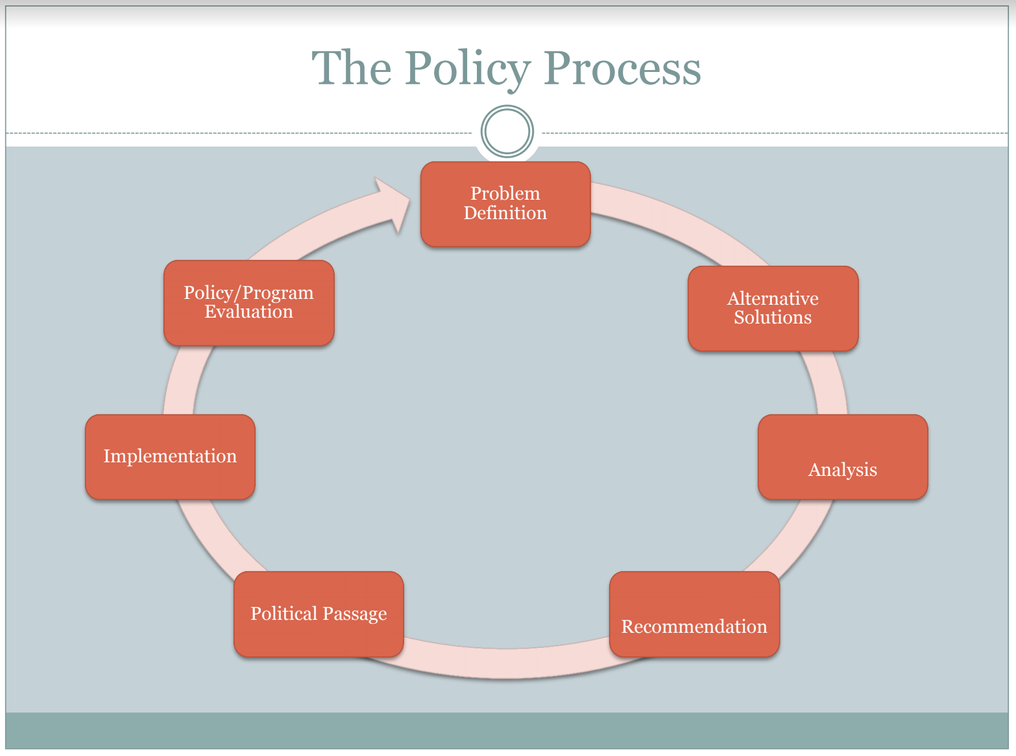
(Analysis, 2021)
to consider whether a conference should move from a three-year to a five-year constituency meeting cycle. The committee first identified the problem, then analyzed available alternatives and considered the implications of each option. After discussion, the committee recommended moving to a five-year cycle. For this recommendation to become part of the conference constitution and bylaws, it required approval by a two-thirds majority.
The proposal generated considerable discussion, but delegates ultimately concluded that a five-year term made sense and voted overwhelmingly to adopt it. The change was approved in 2012, and the conference subsequently held constituency meetings in 2017 and 2022. To date, delegates appear satisfied with the revised timetable and have not requested that the item be reconsidered.
Leadership inevitably involves legal and policy issues. Whether leaders are developing policies that advance mission or addressing legal matters related to land disputes, personnel issues, sexual harassment, or injury cases, they must be prepared to respond wisely, ethically, and responsibly.
This competency has been especially practical and informative because it connects directly to both my past leadership experiences and my current responsibilities. It has reinforced the importance of understanding policy, applying law appropriately, and leading with ethical clarity in service of mission.

Bibliography
Aamodt, A. (2021). Mid-America Union Approves Women’s Ordination. Retrieved from https://spectrummagazine.org/news/mid-america-union-approves-womens-ordination/
Andrews University. (2017). Leadership Handbook 2017-2018. Retrieved from https://www.andrews.edu/sed/leadership_dept/leadership/resources/handbooks
Bhuyan, A., Jorgensen, A., & Sharma, S. (2010). Taking the pulse of policy: The policy implementation assessment tool. Washington, DC: Futures Group. Health Policy Initiative, Task Order, 1, 5.
Coridan, D. (2021, September 12, 2021). Mid-America Union Conference Constituency Meeting, College View SDA Church.
De Neufville, J. I., & Barton, S. E. (1987). Myths and the definition of policy problems: An exploration of home ownership and public-private partnerships. Policy Sciences, 20, 181-206.
Education, D. f. P. (1990). Tort and Religion. Westin Hotel, Boston, MA.
Fagerberg, J. (2017). Innovation policy: Rationales, lessons and challenges. Journal of Economic Surveys, 31(2), 497-512.
Howlett, M. (2012). The lessons of failure: Learning and blame avoidance in public policy-making. International Political Science Review, 33(5), 539-555.
Linkedin (2023, August 9). Retrieved April 24, 2024 from https://www.linkedin.com/pulse/power-policies-ensuring-efficiency-consistency-your
Mthethwa, R. (2012). Critical dimensions for policy implementation.
Network, A. N. (Producer). (2015, April 24, 2024). Delegates Vote “No” On Women’s Ordination. Retrieved from https://adventist.news/news/delegates-vote-no-on-issue-of-womens-ordination
Tremper, C. (1995). Tort Liability for Charitable, Religious and Non-Profit Institutions. Chicago, IL: American Bar Association.
Wikipedia. Retrieved from https://en.wikipedia.org/wiki/Seventh-day_Adventist_Church

Analysis, S. (2021). Policy Wheel. Retrieved from https://www.sciotoanalysis.com/news/2021/3/8/the-policy-wheel-model-of-the-policy-process
Howlett, M. (2012). The lessons of failure: Learning and blame avoidance in public policy-making. International Political Science Review, 33(5), 539-555.
Linkedin (2023, August 9). Retrieved April 24, 2024 from https://www.linkedin.com/pulse/power-policies-ensuring-efficiency-consistency-your

