Andrews University
School of Education

REFLECTION PAPER
LEADERSHIP THROUGH ORGANIZATION:
3D: IMPLEMENTING CHANGE

In Partial Fulfillment
Of the Requirements for the Degree
Doctor of Philosophy

by
Gary F. Thurber
May, 2024
Table of Contents
Introduction: 4
Organization of the Paper 5
Areas of Change 5
Organizational Change at Camp 6
Change Process For MAUC Revolving Fund 9
What I learned from Change Theories 11
References 12

Introduction:
This reflection paper covers section 3d of the competencies for the Leadership PhD program at Andrews University. This section is part of the Leadership Through Organization cluster, as outlined in the Andrews University Leadership Handbook (Andrews University, 2017) which include:
a. Resource development; human and financial—Leadership appropriately allocates and manages human and financial resources for healthy and strategic outcomes.

b. Legal and policy issues—Leadership applies and understands the scope of a legal and policy structure appropriate for their field.

c. Organizational behavior, development, and culture—Leadership understands personal, group, and inter-group behaviors, and how they impact organizational history, needs, and goals.

d. Implementing change—Leadership involves working with others in order to collaboratively shape the vision and strategy for change, as well as being capable of facilitating the change process.

e. Evaluation and assessment—Leadership uses appropriate evaluation and assessment tools to make decisions about programs and plans.
As the Andrews University handbook states it, “This cluster of competencies focuses on the organizational aspects of leadership. Leadership sets direction in ways that facilitate achievement of organizational goals.” (Andrews University, 2017) Having served the Seventh-day Adventist church for over 41 years as a teacher, pastor, youth director and administrator on the conference and union level, I have had the opportunity to see this organization from many points of view. This organization has had a major impact on my ministry and life. I will share some of my journey with this church organization and demonstrate how I integrated my exposure to concepts and theories about organizational change into my practical journey as well as exposing areas for growth.

Organization of the Paper
This paper reflects on my ministry work experience with the SDA Church and changes that took place during my tenure. Some changes were forced on me while others came about as part of my leadership journey. I bring to light the various theories and best practices I have learned during my study about organizational change and how it has impacted the way I was able to contribute to the mission of the SDA through leadership. I give specific examples and share stories which bring to light the integration of my learning and leadership journey.

Areas of Change
Change is hard. This is true on a personal level and especially on a corporate level. Alicia Kritsonis reflects, that “change will occur when the combined strength of one force is greater than the combined strength of the opposing set of forces (Kritsonis, 2005, p. 2). As I have experienced various changes the church has made over the years, I believe Kritsonis has it right. We simply won’t change until we see that our mission and values are not in alignment with our practice. This understanding will bring about change by necessity in order to fulfill our stated ministry goals.
Change then, in the church, has come in many forms. Certainly, we have seen governance policy changes. This happens yearly as the North American Division meets at their Year-end meetings and at that time brings proposed changes to our working policy. Change also comes on a local level through new programs, discarding old programs, and creating new processes for efficiency and clarity.
Change normally comes when we want to execute best practices to grow our mission. Sometimes change takes place in the form of culture. Warner Burke writes, “This systemic target is often organization’s culture, especially the group and organization norms to which members conform” (Burke, 2023, p. 51). Walking into a number of new leadership opportunities, understanding the culture of a church, school, camp, conference or Union, was a must. Other times, organization policy change was what was needed. Whatever the change, there will be forces pushing back; that you can count on.

Organizational Change at Camp
Five of the most rewarding years I served in a leadership role was at a summer camp. Wonderful ministry takes place at a summer camp setting. This is the single greatest place where young people make decisions for Christ.
The camp where I served was not ‘hitting on all cylinders’ when I arrived. The census of campers coming was less than half of the camp’s capacity. Changes needed to be made to bring the camp back in line with it’s stated mission “to lead young people to Christ”. To bring change, however, was going to be costly because the current practices were comfortable for the current camp staff and the constituents they served. In his paper on Lewin’s change theory model, Syed Talib Hussain wrote, “the future of this change is uncertain and may concern the people's worth, coping abilities, and competency, so the people of the organization do not support change unless they are convinced against the status quo” (Hussain et al., 2018).
What Hussain stated was prophetic in my case. Change was difficult to bring because of the comfort of the status quo. As a result, some staff left on their own as a protest to proposed changes, while others were asked to leave because they were not able to adjust to a new paradigm. At times like these, knowing who you are and the stated values and mission of your organization is a must.
What were the needed changes at the camp? Camp staff policies which provided a more equitable schedule for all workers, safety changes to bring the camp to the highest standards in the industry, program changes to bring about a Christ-filled atmosphere all day long for the campers, and finally staff who were unwilling to share in the values and mission of the camp.
Lewin’s tree step change theory whose phases are unfreeze, make necessary changes and refreeze has been studied widely and has been shown through empirical and qualitative studies to be quite effective (Bakari, Hunjra, & Niazi, 2017; Hussain et al., 2018). The first task at hand was to work on unfreezing the status quo of the camp. I started by calling a weekend retreat together of all of the various team leaders of the summer camp program together. The intent was to get to know one another and create a shared vision of how we wanted to implement our summer ministry at camp.
The weekend began by working through our values and mission as a camp. We then began the process to use the employees themselves to identify where needed changes were called for to align with our newly shared vision for camp. Hossain states “For overcoming the resistance in organizational change, the employee involvement is the oldest and most effective strategy in formulating the planning and implementing change. The participation will lead high quality change and prevail over the resistance in implementing stage (Hussain et al., 2018, p. 124). It was amazing to hear the flow of feedback from the leadership team on what and how needed changing in our program. Again, Hussain predicted this when he wrote, “By doing this a variety of information and ideas may be generated, which may contribute the innovations effective and suitable in the situation, raise likelihood, create member commitment in implementing change, and employee motivating and leading change effort in work (Hussain et al., 2018, p. 125).
Another way in which Lewin’s “unfreezing” stage could take place with the staff was when they sensed the camp leadership was being very transparent and vulnerable about what we were trying accomplish with all of the changes. By the time the leadership team weekend was finished, the leadership team was united and focused on what needed to get done for the camp. When the summer camp staff arrived, the various leaders all across the camp were ready to convey in clear and open ways the changes that were going to be taken. Morgan and Zeffane study on trust and change (Morgan & Zeffane, 2003) makes the assertion transparency is a key to leaders building trust and trust in leadership is an essential for effective change.
One thing I learned with changes at the camp which was predicted in Lewin’s model for change is that once the unfreezing takes place, you need to be open for the new directions your course will take you. When thinking about change, if only one person’s mind is responsible for all the needed changes, then the outcomes will be completely limited to the one person’s knowledge and mindset. With the camp leadership team getting involved and being sold on the need for change to align for our values and mission, now we had many minds working on what the change needed to look like. Going another step further, even the general staff, because of the transparency and trust built, felt free to give needed input as to how we could make the camp the best it could be. Bernard Burnes in his study on change came to this conclusion, “Attempts to predict or identify a specific outcome from planned change is very difficult because of the complexity of the forces concerned. Instead, one should seek to take into account all the forces at work and identify and evaluate, on a trial-and-error basis, all the available options (Burnes, 2004, p. 985).
Finally, I noticed changes we made were not sustainable if they did nothing to enhance the mission of the camp an did not include needed policy changes as well as positive oversight to see the changes through. Again, Burnes, in talking about the “refreezing” stage states, “Lewin saw successful change as a group activity, because unless group norms and routines are also transformed, changes to individual behavior will not be sustained. In organizational terms, refreezing often requires changes to organizational culture, norms, policies and practices (Burnes, 2004, p. 986).

Change Process For MAUC Revolving Fund
Organizationally, the change in the Mid-America Union Conference moving from a unregistered revolving fund to a registered one also mirrored Lewin’s three stages for change. When we discovered we were not a registered fund and realized the need to become one, there was much hesitation by the conferences to want to make the change. After all, they had been working with the revolving fund the way it was for over 4 decades without any issues at all from the government oversight entities. This, however, did not give us license to be doing what we were and technically were practicing illegally in ten different states.

The act of “unfreezing” was the most difficult period to accomplish in this needed change. As we discussed the situation with our conference leadership, who are the primary users of the revolving fund, they were not excited about the possible regulations which added more responsibility to their organizations in case of an entity of theirs defaulting on a loan payment. This was predictable according to Lewin’s change theory. As H. E. Schein argued about the unfreezing period, “unless sufficient psychological safety is created, the disconfirming information will be denied or in other ways defended against, no survival anxiety will be felt and consequently, no change will take place (Schein, 1996, p. 61).
Once the unfreezing period was over, the needed changes for our fund began to take shape. Most of the changes came through our legal team working with the state to make sure we would not incur any penalties for not being a registered fund in any of the ten states we operated as a union. As Burnes points out, to accomplish the actions needed for our change, three things had to be present according to Lewin’s theory of change. He sees in the second phase that “Firstly, it emphasizes that change requires action, and is directed at achieving this. Secondly, it recognizes that successful action is based on analyzing the situation correctly, identifying all the possible alternative solutions and choosing the one most appropriate to the situation at hand. To be successful, though, there has also to be a ‘felt-need’. Felt-need is an individual’s inner realization that change is necessary. If felt-need is low in the group or organization, introducing change becomes problematic” (Burnes, 2004, pp. 983-984)
While the felt need was low at first because of the years the fund had operated illegally as an unregistered fund, as the legal team uncovered the problematic nature of remaining an unregistered fund the was unity within our Union that we must move forward.
The refreezing phase was solidified with the various policies that were put in place to satisfy the government’s requirement to be registered legally in all ten states. Again, by making sure the major stakeholders were with us each step of the was critical for the change to take place. If the conferences had not supported the need for change, It would have never taken place. As Hussain summarizes, “At each phase of theprocess model, the leaders and employees are considered to be oneunit, and each phase will be shifted to the next step of the Kurt Lewin’s model” (Hussain et al., 2018, p. 126)

What I learned from Change Theories
I haven’t completed this section as of yet. I will be using the chart below to talk about Lewin’s model and the importance of employee involvement and transparency in the process. I will bring up Lippett’s stages of change theory and how it is mostly just an expansion of Lewin’s theory. I will also touch on Social Cognitive Theory of change and the theory of reasoned action and Planned behavior theory.

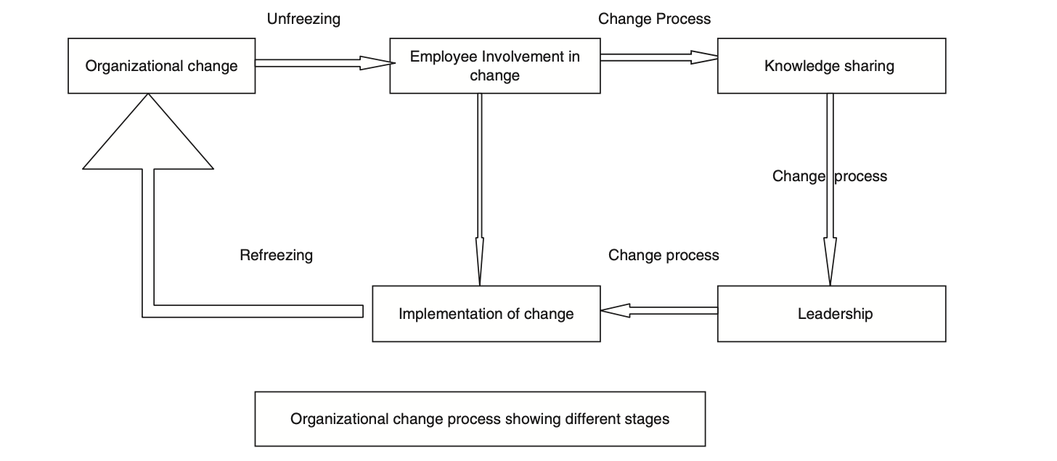

References
Andrews University. (2017). Leadership Handbook 2017-2018. Retrieved from https://www.andrews.edu/sed/leadership_dept/leadership/resources/handbooks
Bakari, H., Hunjra, A. I., & Niazi, G. S. K. (2017). How does authentic leadership influence planned organizational change? The role of employees’ perceptions: Integration of theory of planned behavior and Lewin's three step model. Journal of Change Management, 17(2), 155-187.
Burke, W. W. (2023). Organization change: Theory and practice: Sage publications.
Burnes, B. (2004). Kurt Lewin and the planned approach to change: a re‐appraisal. Journal of Management studies, 41(6), 977-1002.
Hussain, S. T., Lei, S., Akram, T., Haider, M. J., Hussain, S. H., & Ali, M. (2018). Kurt Lewin's change model: A critical review of the role of leadership and employee involvement in organizational change. Journal of innovation & knowledge, 3(3), 123-127.
Kritsonis, A. (2005). Comparison of change theories. International journal of scholarly academic intellectual diversity, 8(1), 1-7.
Morgan, D., & Zeffane, R. (2003). Employee involvement, organizational change and trust in management. International journal of human resource management, 14(1), 55-75.
Schein, E. H. (1996). Culture: The missing concept in organization studies. Administrative science quarterly, 229-240.

